**Laboratory Program - 1**

**Genetic Algorithm for Optimization Problems**

Genetic Algorithms (GA) are inspired by the process of natural selection and genetics, where

the fittest individuals are selected for reproduction to produce the next generation. GAs are

widely used for solving optimization and search problems. Implement a Genetic Algorithm

using Python to solve a basic optimization problem, such as finding the maximum value of a

mathematical function.

Algorithm

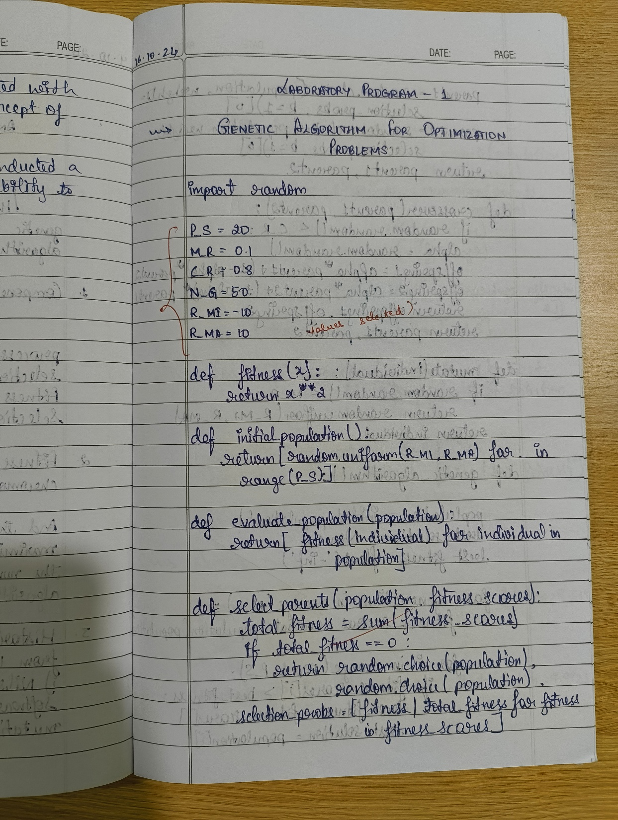

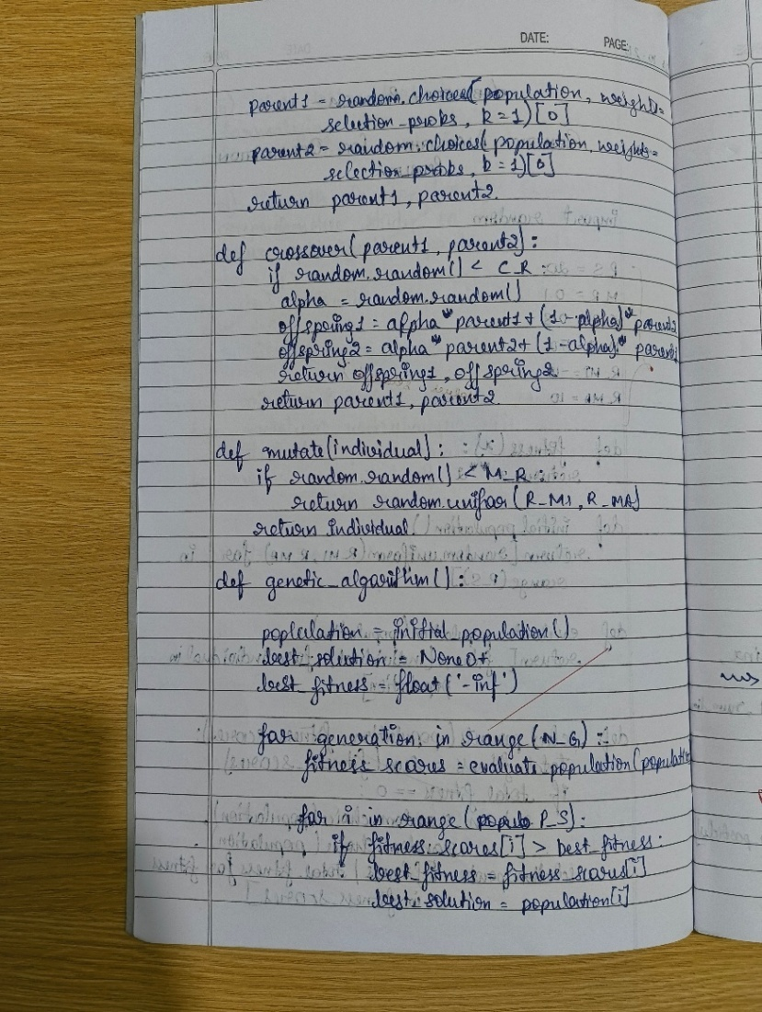

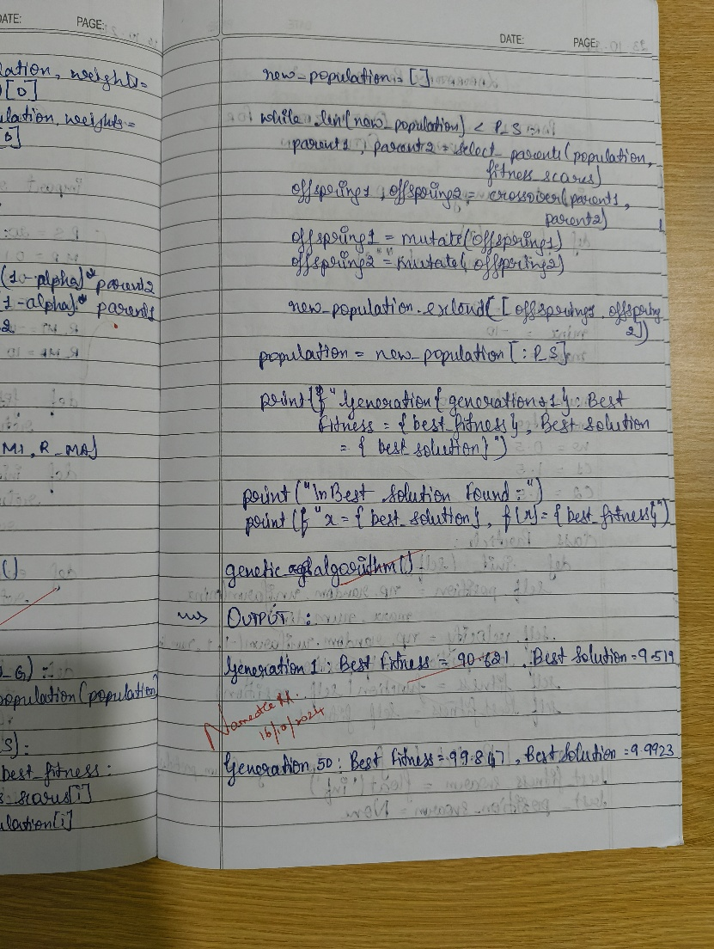

Code

import random

def fitness_function(x, y):

return x ** 2

population_size = 100

mutation_rate = 0.1

crossover_rate = 0.8

num_generations = 50

variable_bounds = [-10, 10]

def initialize_population(population_size, bounds):

population = []

for _ in range(population_size):

x = random.uniform(bounds[0], bounds[1])

y = random.uniform(bounds[0], bounds[1])

population.append([x, y])

return population

def evaluate_population(population):

fitness_scores = []

for individual in population:

fitness_scores.append(fitness_function(individual[0], individual[1]))

return fitness_scores

def selection(population, fitness_scores):

total_fitness = sum(fitness_scores)

selected_population = []

for _ in range(len(population)):

pick = random.uniform(0, total_fitness)

current = 0

for individual, score in zip(population, fitness_scores):

current += score

if current > pick:

selected_population.append(individual)

break

return selected_population

def crossover(parent1, parent2, crossover_rate):

if random.random() < crossover_rate:

crossover_point = random.randint(1, len(parent1) - 1)

child1 = parent1[:crossover_point] + parent2[crossover_point:]

child2 = parent2[:crossover_point] + parent1[crossover_point:]

else:

child1, child2 = parent1, parent2

return child1, child2

def mutate(individual, mutation_rate, bounds):

if random.random() < mutation_rate:

mutation_position = random.randint(0, len(individual) - 1)

mutation_value = random.uniform(bounds[0], bounds[1])

individual[mutation_position] = mutation_value

return individual

def genetic_algorithm():

# Display student information at the start

print("Student Name: Likhith M")

print("USN: 1BM22CS135")

print("-" * 40)

population = initialize_population(population_size, variable_bounds)

overall_best_solution = None

overall_best_fitness = float('-inf')

for generation in range(num_generations):

fitness_scores = evaluate_population(population)

generation_best_fitness = max(fitness_scores)

generation_best_solution = population[fitness_scores.index(generation_best_fitness)]

if generation_best_fitness > overall_best_fitness:

overall_best_fitness = generation_best_fitness

overall_best_solution = generation_best_solution

# Displaying the output for generations that are multiples of 10

if (generation + 1) % 10 == 0:

print(f"Generation {generation + 1}:")

print(f" Best fitness = {generation_best_fitness}")

print(f" Best solution = {generation_best_solution}")

print("-" * 40)

selected_population = selection(population, fitness_scores)

next_population = []

for i in range(0, population_size, 2):

parent1 = selected_population[i]

parent2 = selected_population[i + 1]

child1, child2 = crossover(parent1, parent2, crossover_rate)

child1 = mutate(child1, mutation_rate, variable_bounds)

child2 = mutate(child2, mutation_rate, variable_bounds)

next_population.append(child1)

next_population.append(child2)

population = next_population

print(f"Best solution found after {num_generations} generations: {overall_best_solution}")

print(f"Best fitness value: {overall_best_fitness}")

genetic_algorithm()

Output

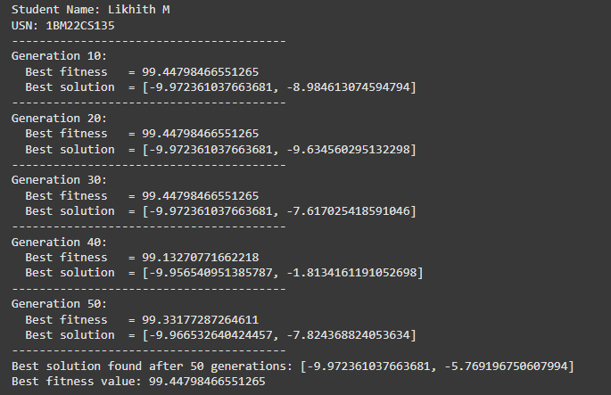

**Laboratory Program - 2**

**Particle Swarm Optimization for Function Optimization**

Particle Swarm Optimization (PSO) is inspired by the social behavior of birds flocking or fish schooling. PSO is used to find optimal solutions by iteratively improving a candidate solution with regard to a given measure of quality. Implement the PSO algorithm using Python to optimize a mathematical function.

Algorithm

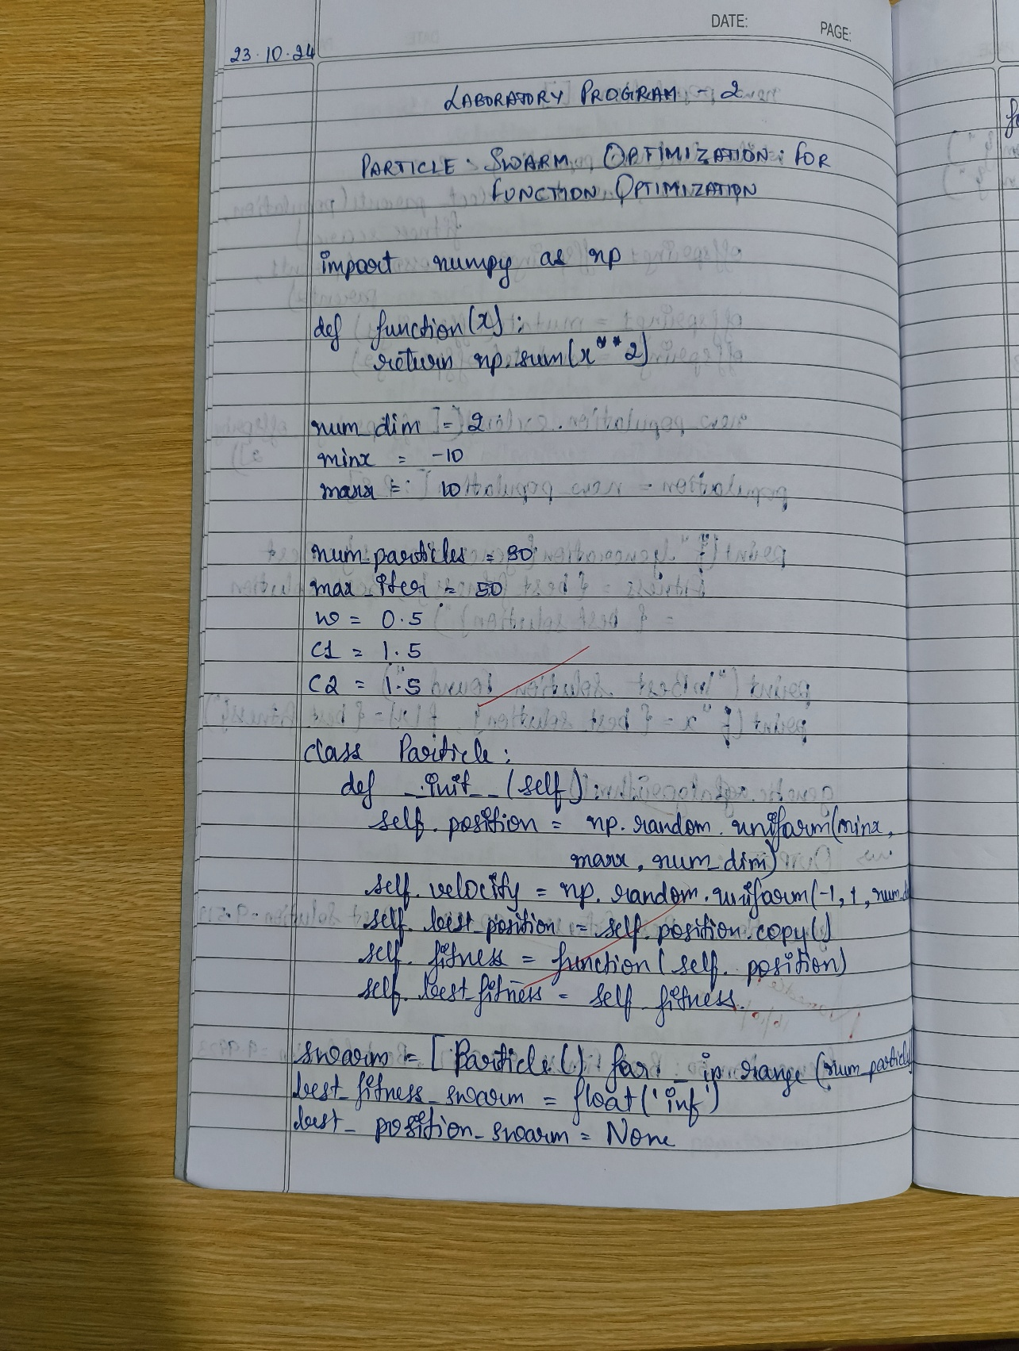

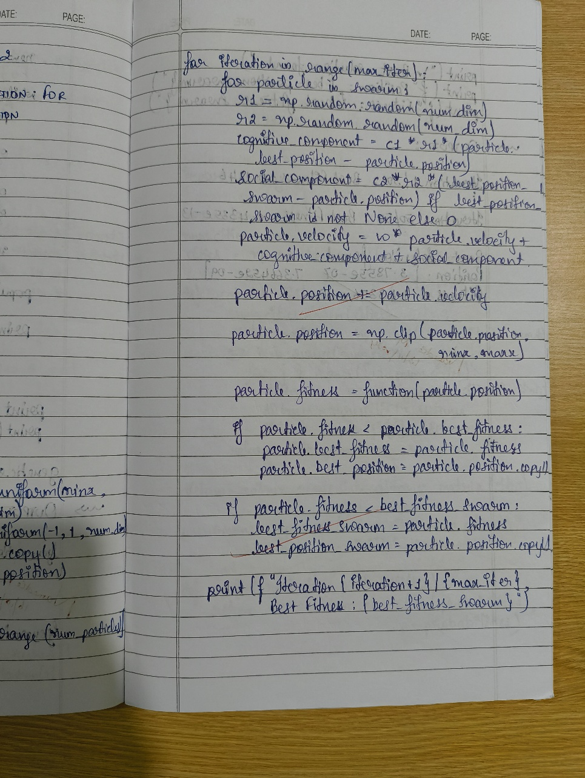

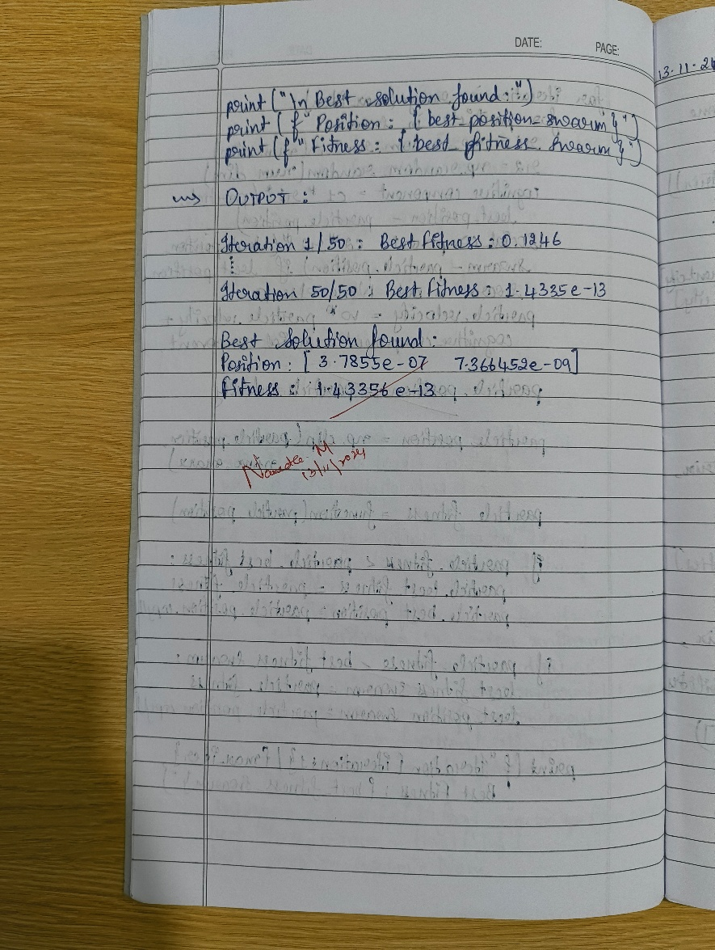

Code

import numpy as np

import matplotlib.pyplot as plt

# Student Details

print("Student Name: Likhith M")

print("USN: 1BM22CS135\n")

# Objective function (Rastrigin function as an example)

def rastrigin(x):

    A = 10

    return A * len(x) + sum(x_i**2 - A * np.cos(2 * np.pi * x_i) for x_i in x)

# PSO Parameters

n_particles = 30     # Number of particles

n_dimensions = 2     # Number of dimensions (parameters to optimize)

n_iterations = 100   # Number of iterations

w = 0.5              # Inertia weight

c1 = 1.5             # Cognitive coefficient (particle's own best position)

c2 = 1.5             # Social coefficient (global best position)

v_max = 2.0          # Maximum velocity

# Initialize particles' positions and velocities

positions = np.random.uniform(-5.12, 5.12, (n_particles, n_dimensions))

velocities = np.random.uniform(-1, 1, (n_particles, n_dimensions))

# Initialize personal best positions and global best position

pbest_positions = positions.copy()

pbest_values = np.apply_along_axis(rastrigin, 1, pbest_positions)

gbest_position = pbest_positions[np.argmin(pbest_values)]

gbest_value = np.min(pbest_values)

# PSO Main Loop

for t in range(n_iterations):

    # Evaluate fitness

    fitness_values = np.apply_along_axis(rastrigin, 1, positions)

    # Update personal bests

    for i in range(n_particles):

        if fitness_values[i] < pbest_values[i]:

            pbest_positions[i] = positions[i]

            pbest_values[i] = fitness_values[i]

    # Update global best

    min_fitness_idx = np.argmin(pbest_values)

    if pbest_values[min_fitness_idx] < gbest_value:

        gbest_position = pbest_positions[min_fitness_idx]

        gbest_value = pbest_values[min_fitness_idx]

    # Update velocity and position for each particle

    r1 = np.random.rand(n_particles, n_dimensions)

    r2 = np.random.rand(n_particles, n_dimensions)

    velocities = (w * velocities +

                  c1 * r1 * (pbest_positions - positions) +

                  c2 * r2 * (gbest_position - positions))

    # Apply velocity limits (optional)

    velocities = np.clip(velocities, -v_max, v_max)

    # Update positions

    positions = positions + velocities

    # Print the current best solution only for multiples of 10

    if t % 10 == 0:

        print(f"Iteration {t}, Global Best Value: {gbest_value:.5f}")

# Final output

print(f"\nFinal Global Best Position: {gbest_position}")

print(f"Final Global Best Value: {gbest_value:.5f}")

# Plotting the optimization process (visualization for 2D case)

x_vals = np.linspace(-5.12, 5.12, 400)

y_vals = np.linspace(-5.12, 5.12, 400)

X, Y = np.meshgrid(x_vals, y_vals)

Z = rastrigin([X, Y])

plt.contour(X, Y, Z, levels=np.linspace(0, 500, 50), cmap='jet')

plt.scatter(gbest_position[0], gbest_position[1], color='red', label='Global Best')

plt.title("PSO Optimization (Rastrigin Function)")

plt.xlabel('x1')

plt.ylabel('x2')

plt.legend()

plt.show()

Output

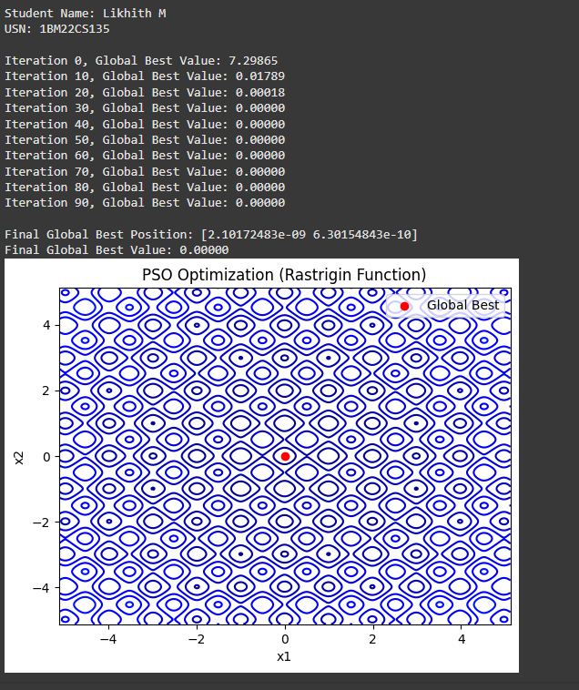

**Laboratory Program - 3**

**Ant Colony Optimization for the Traveling Salesman Problem**

The foraging behavior of ants has inspired the development of optimization algorithms that can solve complex problems such as the Traveling Salesman Problem (TSP). Ant Colony Optimization (ACO) simulates the way ants find the shortest path between food sources and their nest. Implement the ACO algorithm using Python to solve the TSP, where the objective is to find the shortest possible route that visits a list of cities and returns to the origin city.

Algorithm

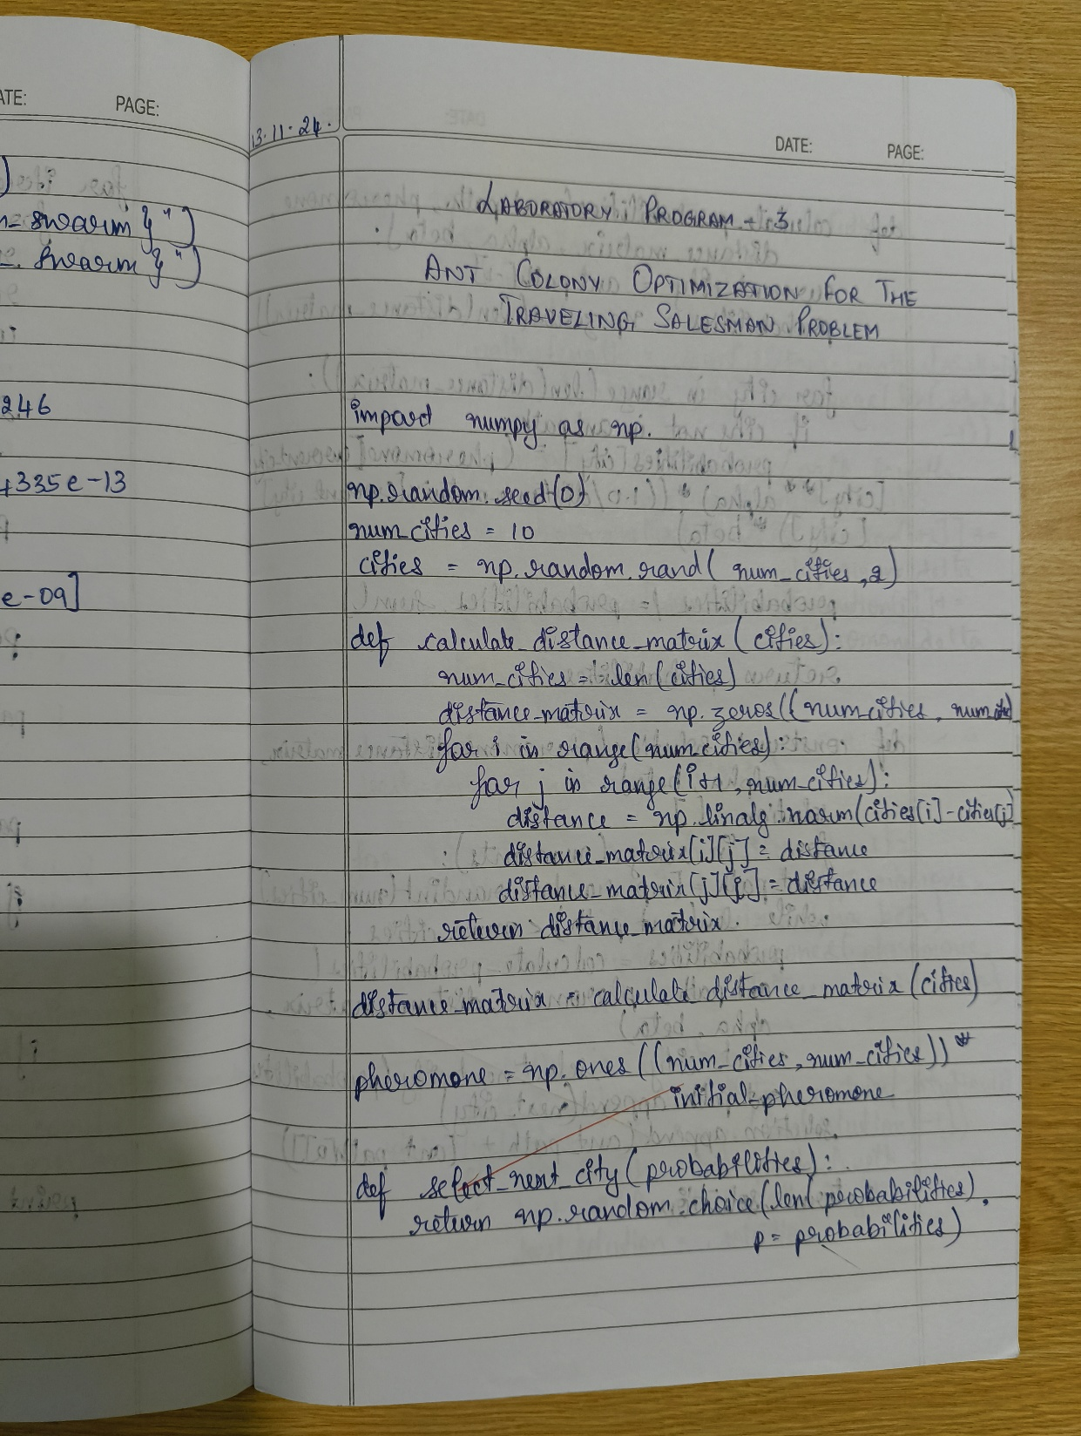

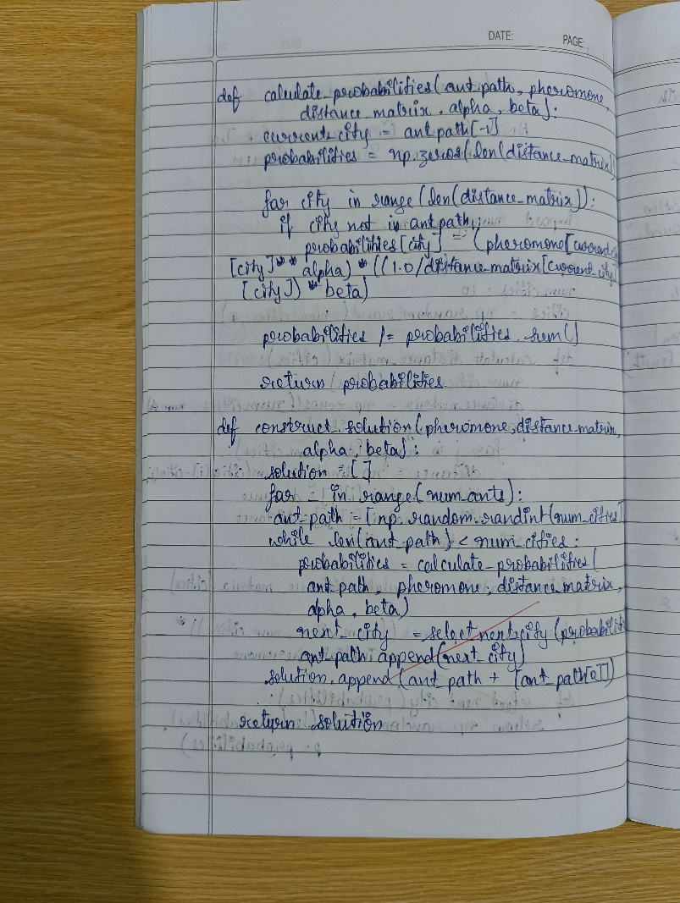

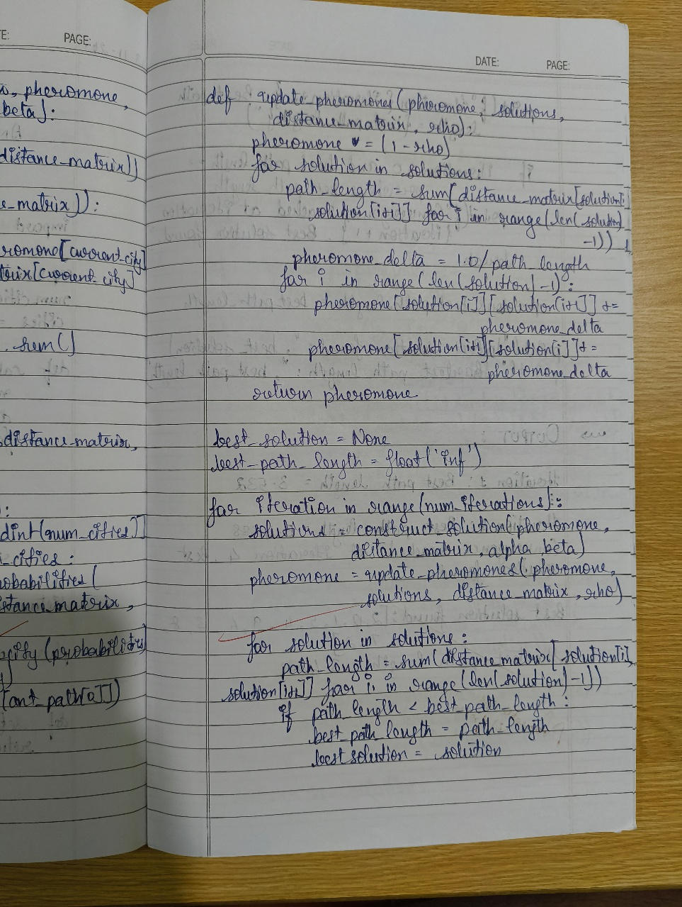

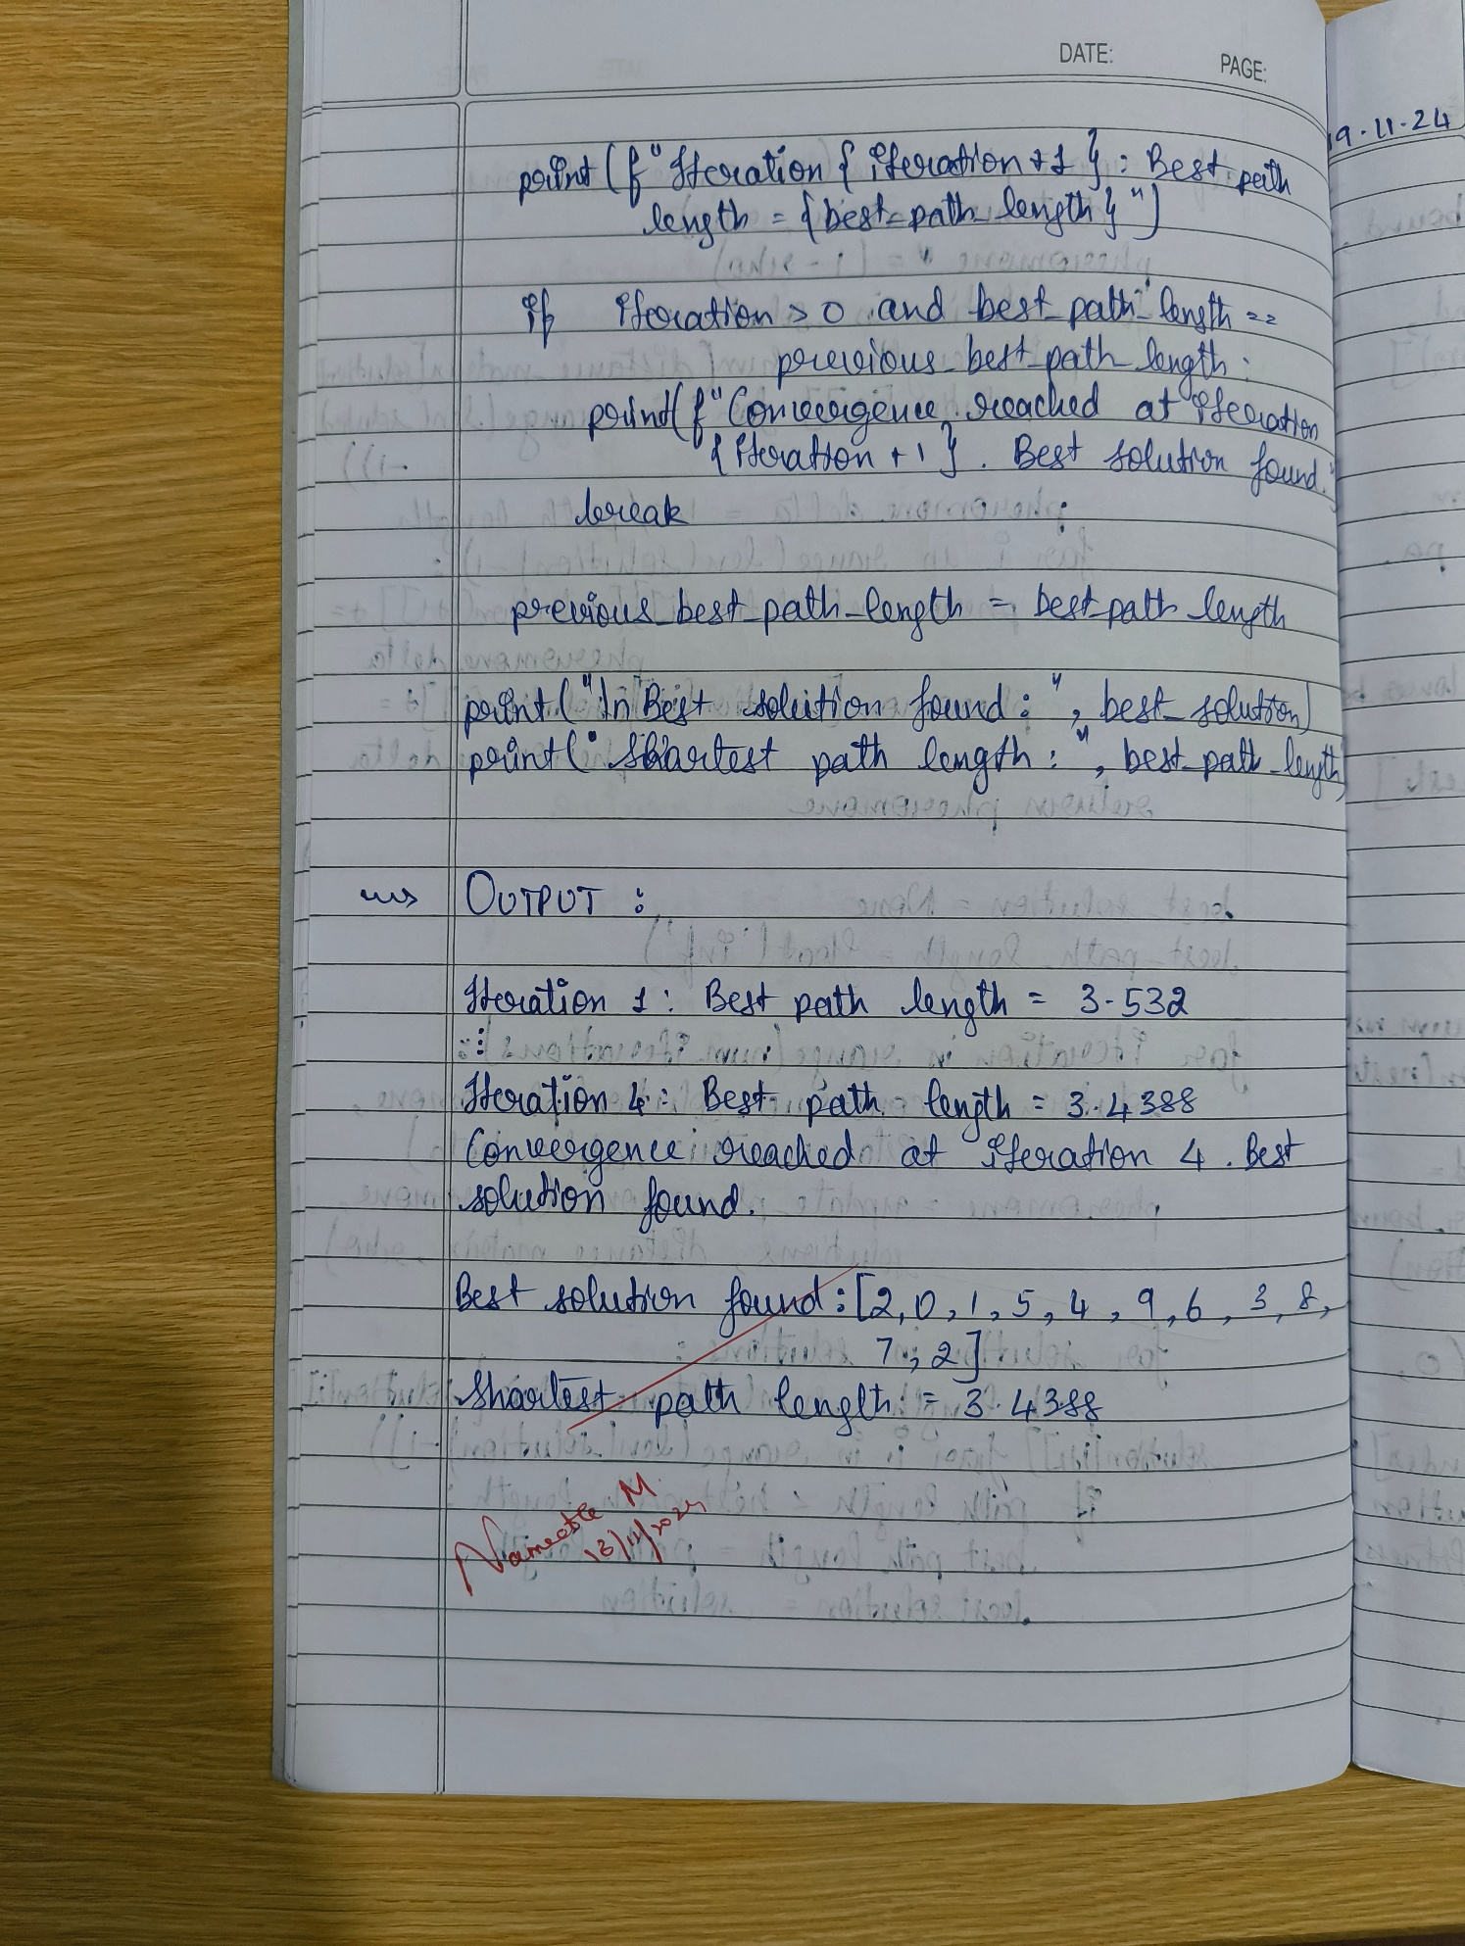

Code

import numpy as np

# Student Details

print("Student Name: Likhith M")

print("USN: 1BM22CS135\n")

np.random.seed(0)

# Problem Parameters

num_cities = 10

num_ants = 20

alpha = 1.0

beta = 5.0

rho = 0.5

initial_pheromone = 0.1

num_iterations = 100

# Generate Random Cities

cities = np.random.rand(num_cities, 2)

# Distance Matrix Calculation

def calculate_distance_matrix(cities):

num_cities = len(cities)

distance_matrix = np.zeros((num_cities, num_cities))

for i in range(num_cities):

for j in range(i + 1, num_cities):

distance = np.linalg.norm(cities[i] - cities[j])

distance_matrix[i][j] = distance

distance_matrix[j][i] = distance

return distance_matrix

distance_matrix = calculate_distance_matrix(cities)

# Initialize Pheromone Matrix

pheromone = np.ones((num_cities, num_cities)) * initial_pheromone

# City Selection

def select_next_city(probabilities):

return np.random.choice(len(probabilities), p=probabilities)

# Probability Calculation

def calculate_probabilities(ant_path, pheromone, distance_matrix, alpha, beta):

current_city = ant_path[-1]

probabilities = np.zeros(len(distance_matrix))

for city in range(len(distance_matrix)):

if city not in ant_path:

probabilities[city] = (pheromone[current_city][city] ** alpha) * ((1.0 / distance_matrix[current_city][city]) ** beta)

probabilities /= probabilities.sum()

return probabilities

# Solution Construction

def construct_solution(pheromone, distance_matrix, alpha, beta):

solution = []

for _ in range(num_ants):

ant_path = [np.random.randint(num_cities)]

while len(ant_path) < num_cities:

probabilities = calculate_probabilities(ant_path, pheromone, distance_matrix, alpha, beta)

next_city = select_next_city(probabilities)

ant_path.append(next_city)

solution.append(ant_path + [ant_path[0]])

return solution

# Pheromone Update

def update_pheromones(pheromone, solutions, distance_matrix, rho):

pheromone *= (1 - rho)

for solution in solutions:

path_length = sum(distance_matrix[solution[i], solution[i+1]] for i in range(len(solution) - 1))

pheromone_delta = 1.0 / path_length

for i in range(len(solution) - 1):

pheromone[solution[i]][solution[i + 1]] += pheromone_delta

pheromone[solution[i + 1]][solution[i]] += pheromone_delta

return pheromone

# Optimization Process

best_solution = None

best_path_length = float('inf')

for iteration in range(num_iterations):

solutions = construct_solution(pheromone, distance_matrix, alpha, beta)

pheromone = update_pheromones(pheromone, solutions, distance_matrix, rho)

for solution in solutions:

path_length = sum(distance_matrix[solution[i], solution[i + 1]] for i in range(len(solution) - 1))

if path_length < best_path_length:

best_path_length = path_length

best_solution = solution

# Display output only for multiples of 10

if (iteration + 1) % 10 == 0:

print(f"Iteration {iteration + 1}: Path length = {best_path_length:.5f}")

# Check for convergence

if iteration > 0 and best_path_length == previous_best_path_length:

print(f"Convergence reached at iteration {iteration + 1}. Best solution found.")

break

previous_best_path_length = best_path_length

# Final Output

print("\nBest solution found:", best_solution)

print("Shortest path length:", best_path_length)

Output

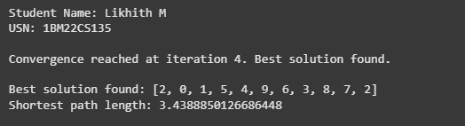

**Laboratory Program - 4**

**Cuckoo Search (CS)**

Cuckoo Search (CS) is a nature-inspired optimization algorithm based on the brood parasitism of some cuckoo species. This behavior involves laying eggs in the nests of other birds, leading to the optimization of survival strategies. CS uses Lévy flights to generate new solutions, promoting global search capabilities and avoiding local minima. The algorithm is widely used for solving continuous optimization problems and has applications in various domains, including engineering design, machine learning, and data mining.

Algorithm

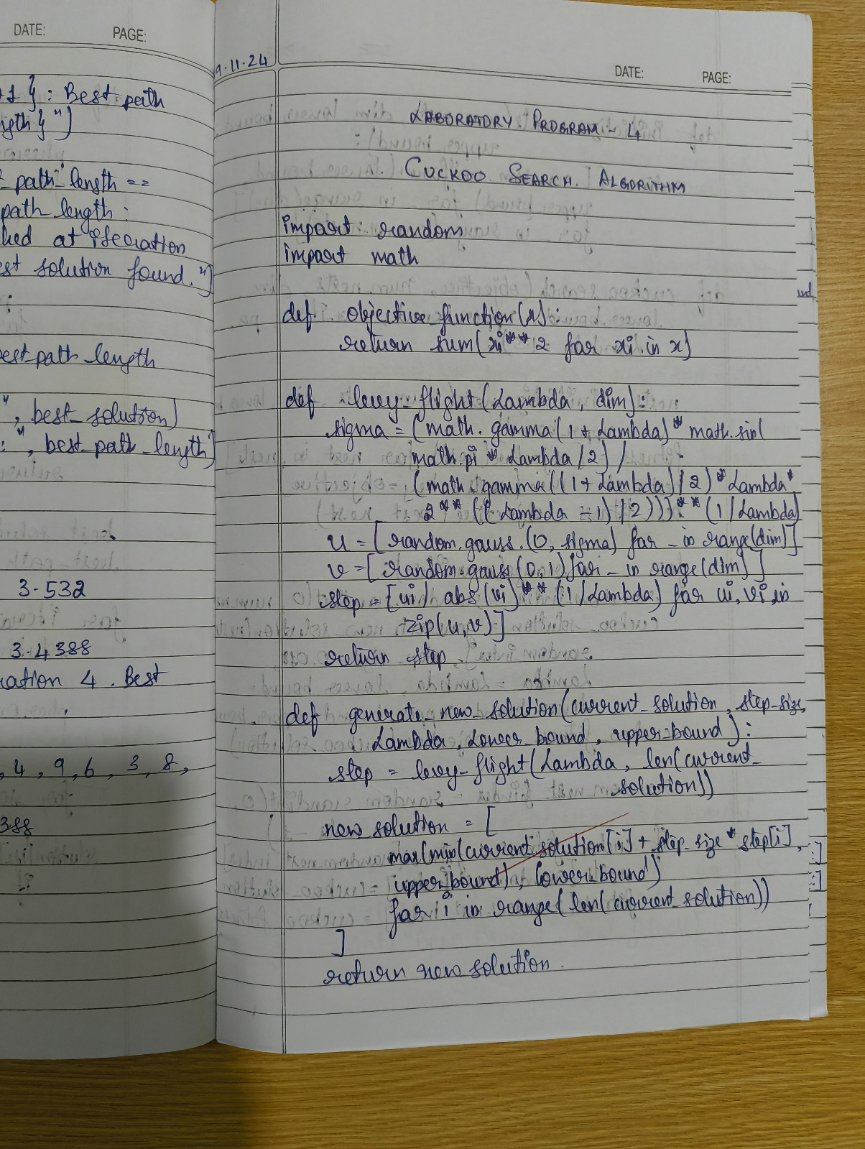

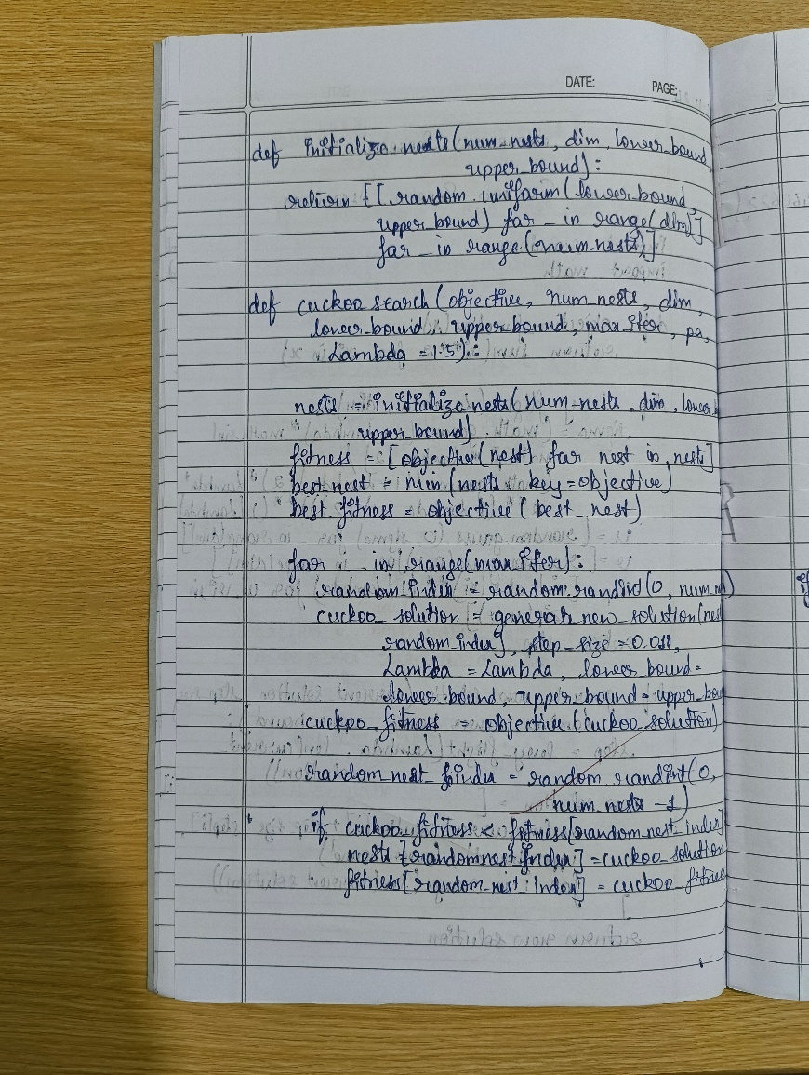

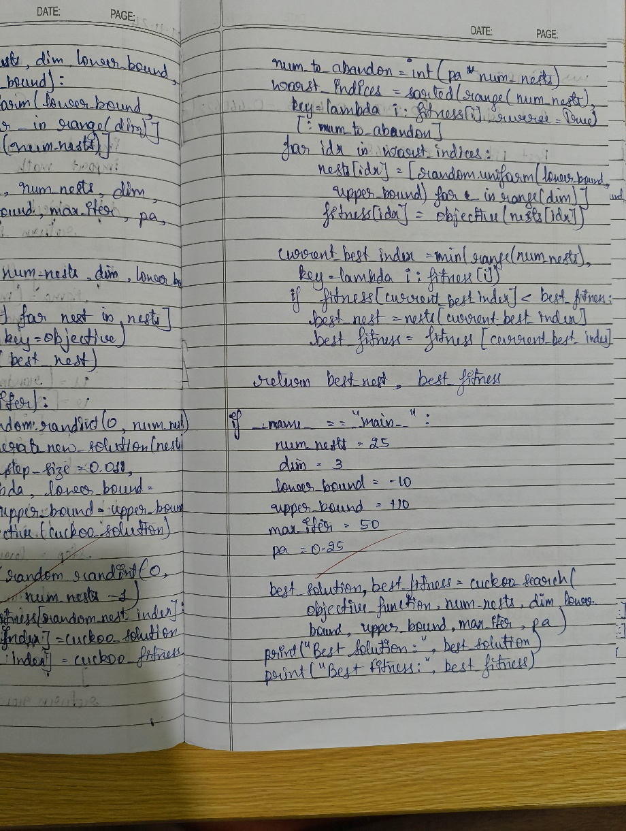

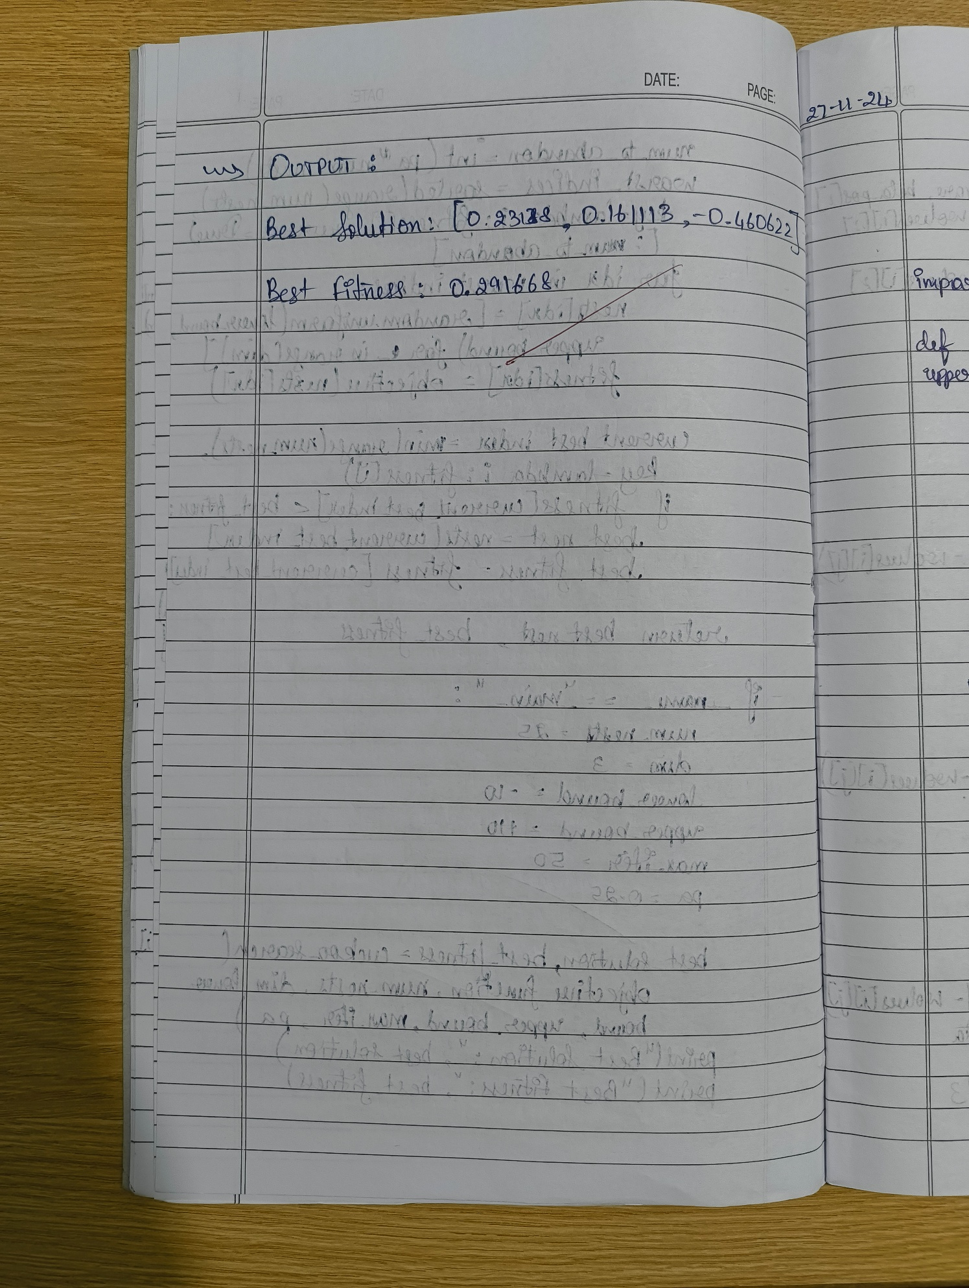

Code

import random

import math

# Student Details

print("Student Name: Likhith M")

print("USN: 1BM22CS135\n")

# Objective Function

def objective_function(x):

return sum(xi ** 2 for xi in x)

# Levy Flight Step

def levy_flight(Lambda, dim):

sigma = (math.gamma(1 + Lambda) * math.sin(math.pi * Lambda / 2) /

(math.gamma((1 + Lambda) / 2) * Lambda * 2 ** ((Lambda - 1) / 2))) ** (1 / Lambda)

u = [random.gauss(0, sigma) for _ in range(dim)]

v = [random.gauss(0, 1) for _ in range(dim)]

step = [ui / abs(vi) ** (1 / Lambda) for ui, vi in zip(u, v)]

return step

# Generate New Solution

def generate_new_solution(current_solution, alpha, Lambda, lower_bound, upper_bound):

step = levy_flight(Lambda, len(current_solution))

new_solution = [

max(min(current_solution[i] + alpha * step[i], upper_bound), lower_bound)

for i in range(len(current_solution))

]

return new_solution

# Initialize Nests

def initialize_nests(n_nests, dim, lower_bound, upper_bound):

return [[random.uniform(lower_bound, upper_bound) for _ in range(dim)] for _ in range(n_nests)]

# Cuckoo Search Algorithm

def cuckoo_search(objective, n_nests, max_iter, alpha, pa, lower_bound=-10, upper_bound=10, Lambda=1.5):

nests = initialize_nests(n_nests, 2, lower_bound, upper_bound)

fitness = [objective(nest) for nest in nests]

best_nest = min(nests, key=objective)

best_fitness = objective(best_nest)

for iteration in range(max_iter):

random_index = random.randint(0, n_nests - 1)

cuckoo_solution = generate_new_solution(nests[random_index], alpha, Lambda, lower_bound, upper_bound)

cuckoo_fitness = objective(cuckoo_solution)

random_nest_index = random.randint(0, n_nests - 1)

if cuckoo_fitness < fitness[random_nest_index]:

nests[random_nest_index] = cuckoo_solution

fitness[random_nest_index] = cuckoo_fitness

num_to_abandon = int(pa * n_nests)

worst_indices = sorted(range(n_nests), key=lambda i: fitness[i], reverse=True)[:num_to_abandon]

for idx in worst_indices:

nests[idx] = [random.uniform(lower_bound, upper_bound) for _ in range(2)]

fitness[idx] = objective(nests[idx])

current_best_index = min(range(n_nests), key=lambda i: fitness[i])

if fitness[current_best_index] < best_fitness:

best_nest = nests[current_best_index]

best_fitness = fitness[current_best_index]

# Output every 100 iterations

if iteration % 100 == 0 or iteration == max_iter - 1:

print(f"Iteration {iteration}, Best Fitness: {best_fitness:.5f}, Best Solution: {best_nest}")

return best_nest, best_fitness

# Main Function

if __name__ == "__main__":

n_nests = 25 # Number of nests

max_iter = 1000 # Maximum iterations

alpha = 0.1 # Step size

pa = 0.25 # Probability of abandoning worse nests

best_solution, best_value = cuckoo_search(

objective_function, n_nests=n_nests, max_iter=max_iter, alpha=alpha, pa=pa

)

print(f"\nBest solution found: x = {best_solution[0]:.5f}, y = {best_solution[1]:.5f}")

print(f"Best objective function value: {best_value:.5f}")

Output

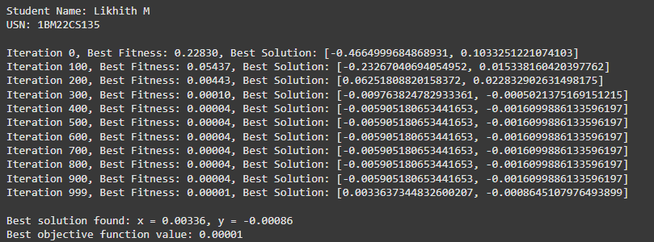

**Laboratory Program - 5**

**Grey Wolf Optimizer (GWO)**

The Grey Wolf Optimizer (GWO) algorithm is a swarm intelligence algorithm inspired by the social hierarchy and hunting behavior of grey wolves. It mimics the leadership structure of alpha, beta, delta, and omega wolves and their collaborative hunting strategies. The GWO algorithm uses these social hierarchies to model the optimization process, where the alpha wolves guide the search process while beta and delta wolves assist in refining the search direction. This algorithm is effective for continuous optimization problems and has applications in engineering, data analysis, and machine learning.

Algorithm

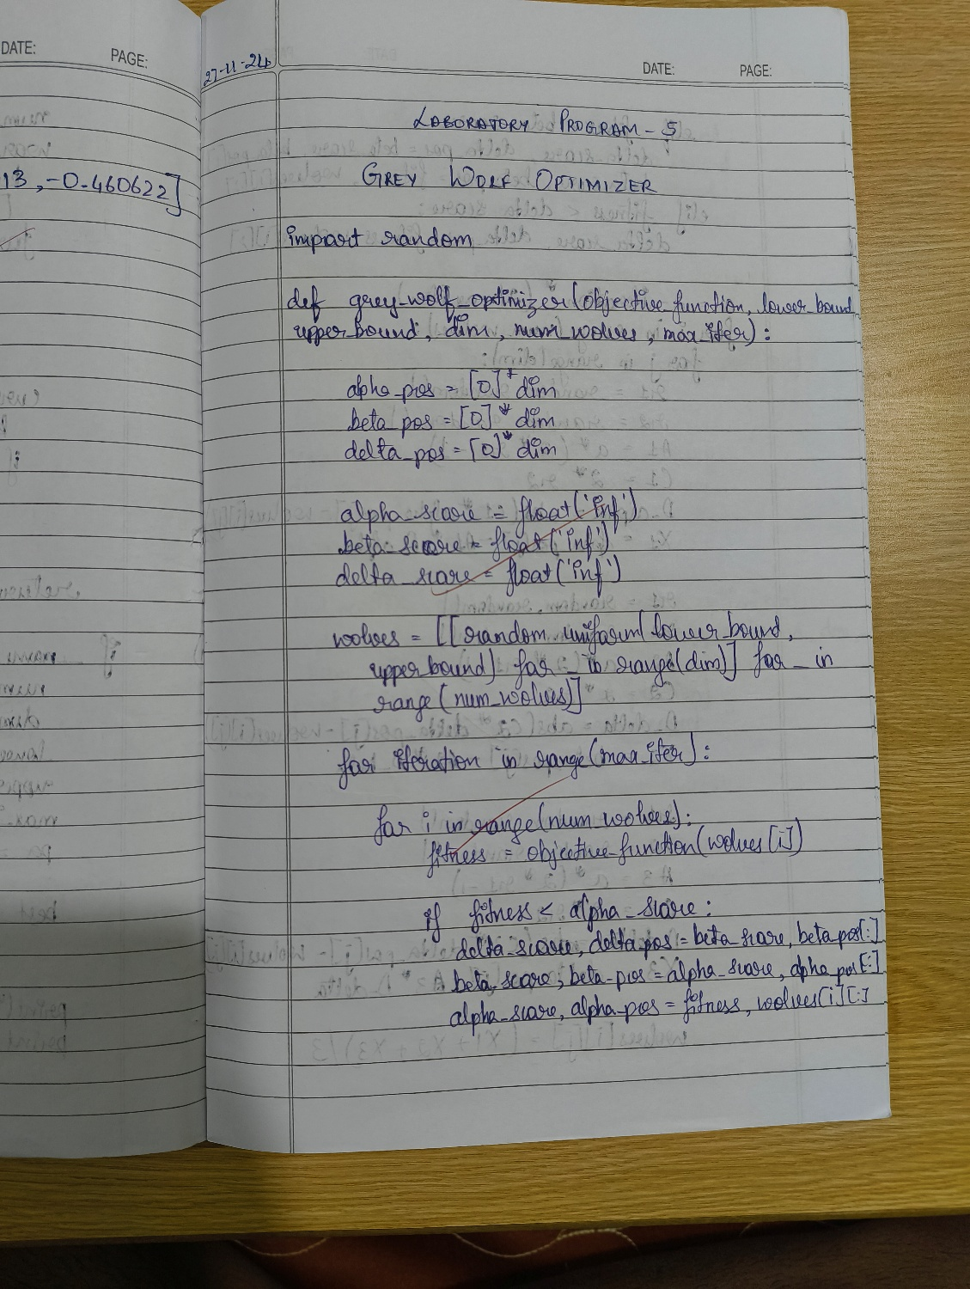

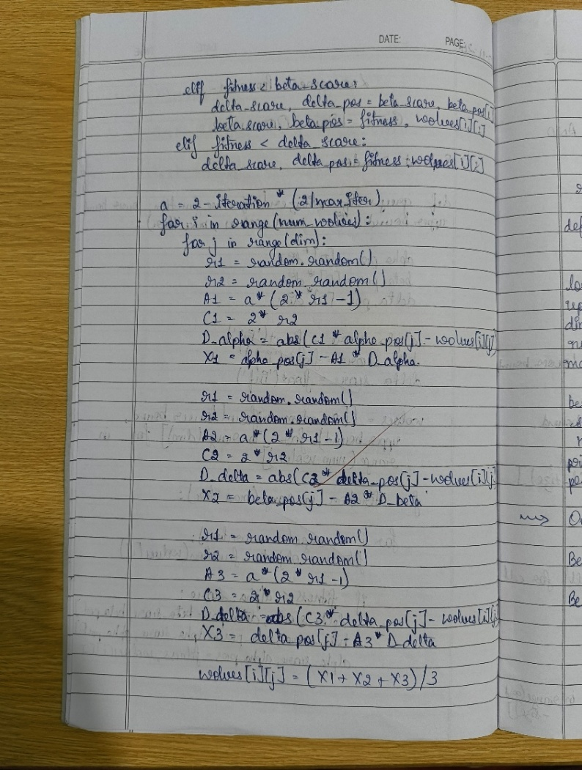

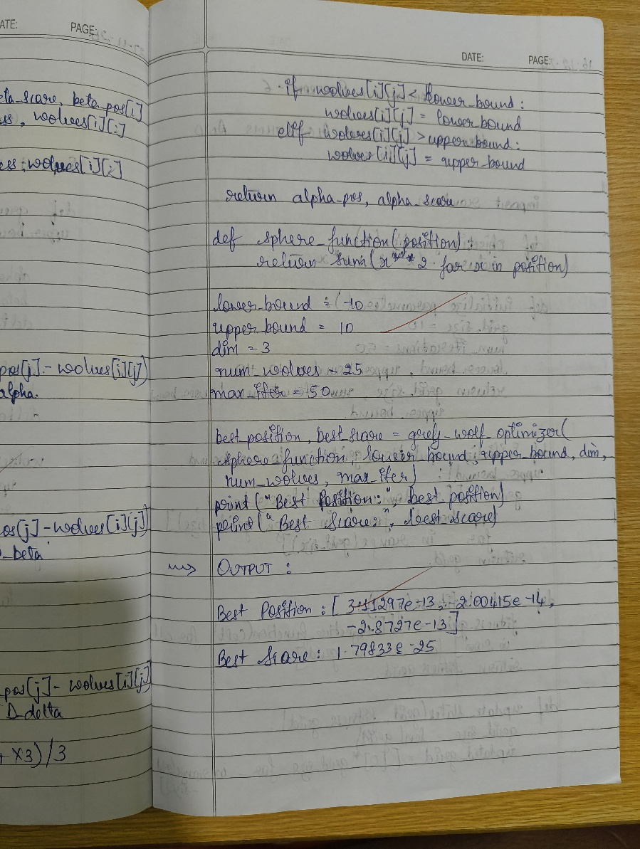

Code

import random

# Student Details

print("Student Name: Likhith M")

print("USN: 1BM22CS135\n")

# Grey Wolf Optimizer Function

def grey_wolf_optimizer(objective_function, lower_bound, upper_bound, dim, num_wolves, max_iter):

alpha_pos = [0] * dim

beta_pos = [0] * dim

delta_pos = [0] * dim

alpha_score = float('inf')

beta_score = float('inf')

delta_score = float('inf')

wolves = [[random.uniform(lower_bound, upper_bound) for _ in range(dim)] for _ in range(num_wolves)]

for iteration in range(max_iter):

for i in range(num_wolves):

fitness = objective_function(wolves[i])

if fitness < alpha_score:

delta_score, delta_pos = beta_score, beta_pos[:]

beta_score, beta_pos = alpha_score, alpha_pos[:]

alpha_score, alpha_pos = fitness, wolves[i][:]

elif fitness < beta_score:

delta_score, delta_pos = beta_score, beta_pos[:]

beta_score, beta_pos = fitness, wolves[i][:]

elif fitness < delta_score:

delta_score, delta_pos = fitness, wolves[i][:]

a = 2 - iteration * (2 / max_iter)

for i in range(num_wolves):

for j in range(dim):

r1 = random.random()

r2 = random.random()

A1 = a * (2 * r1 - 1)

C1 = 2 * r2

D_alpha = abs(C1 * alpha_pos[j] - wolves[i][j])

X1 = alpha_pos[j] - A1 * D_alpha

r1 = random.random()

r2 = random.random()

A2 = a * (2 * r1 - 1)

C2 = 2 * r2

D_beta = abs(C2 * beta_pos[j] - wolves[i][j])

X2 = beta_pos[j] - A2 * D_beta

r1 = random.random()

r2 = random.random()

A3 = a * (2 * r1 - 1)

C3 = 2 * r2

D_delta = abs(C3 * delta_pos[j] - wolves[i][j])

X3 = delta_pos[j] - A3 * D_delta

wolves[i][j] = (X1 + X2 + X3) / 3

if wolves[i][j] < lower_bound:

wolves[i][j] = lower_bound

elif wolves[i][j] > upper_bound:

wolves[i][j] = upper_bound

# Output every 10 iterations

if iteration % 10 == 0 or iteration == max_iter - 1:

print(f"Iteration {iteration}: Best Score = {alpha_score:.5f}, Best Position = {alpha_pos}")

return alpha_pos, alpha_score

# Sphere Function (Objective Function)

def sphere_function(position):

return sum(x ** 2 for x in position)

# Problem Parameters

lower_bound = -10

upper_bound = 10

dim = 3

num_wolves = 25

max_iter = 50

# Run Grey Wolf Optimizer

best_position, best_score = grey_wolf_optimizer(sphere_function, lower_bound, upper_bound, dim, num_wolves, max_iter)

# Final Output

print("\nFinal Best Position:", best_position)

print("Final Best Score:", best_score)

Output

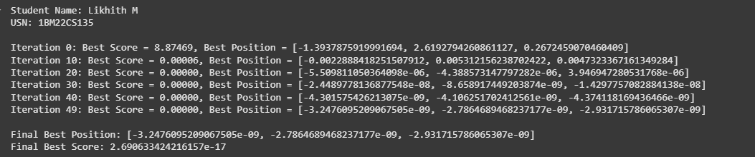

**Laboratory Program - 6**

**Parallel Cellular Algorithms and Programs**

Parallel Cellular Algorithms are inspired by the functioning of biological cells that operate in a highly parallel and distributed manner. These algorithms leverage the principles of cellular automata and parallel computing to solve complex optimization problems efficiently. Each cell represents a potential solution and interacts with its neighbors to update its state based on predefined rules. This interaction models the diffusion of information across the cellular grid, enabling the algorithm to explore the search space effectively. Parallel Cellular Algorithms are particularly suitable for large-scale optimization problems and can be implemented on parallel computing architectures for enhanced performance.

Algorithm

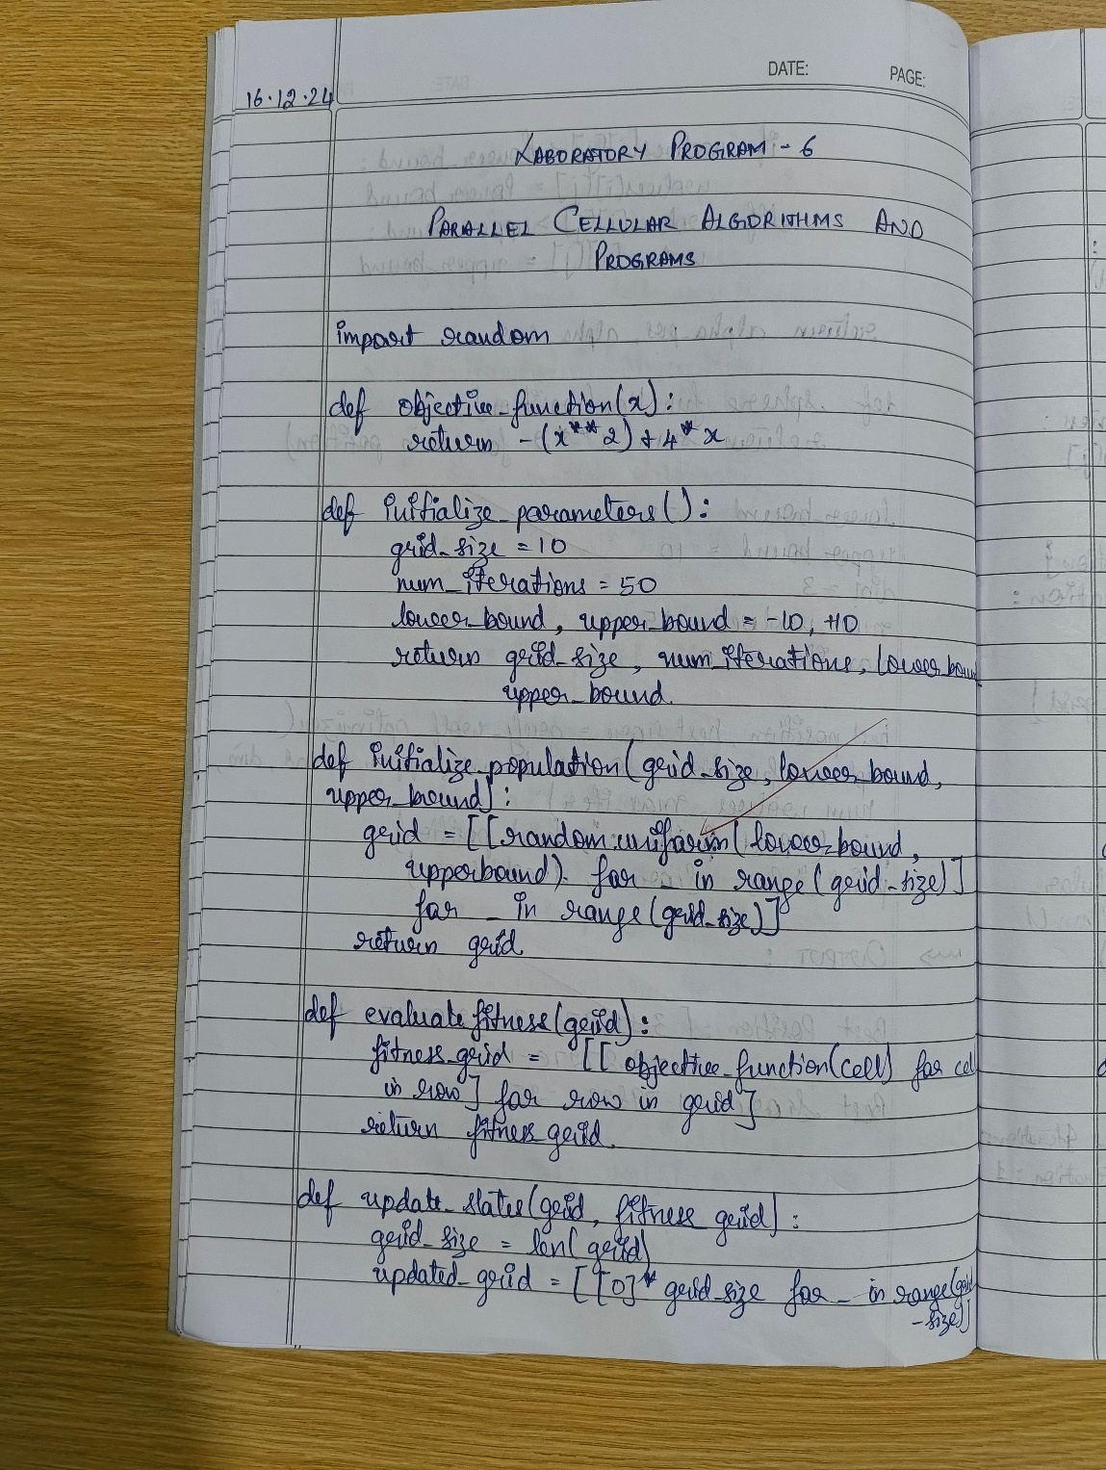

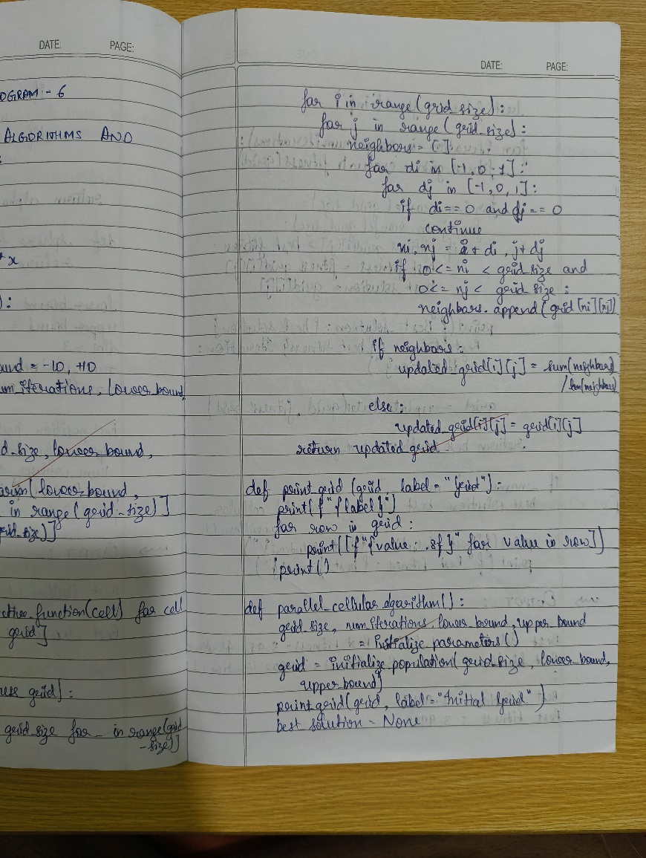

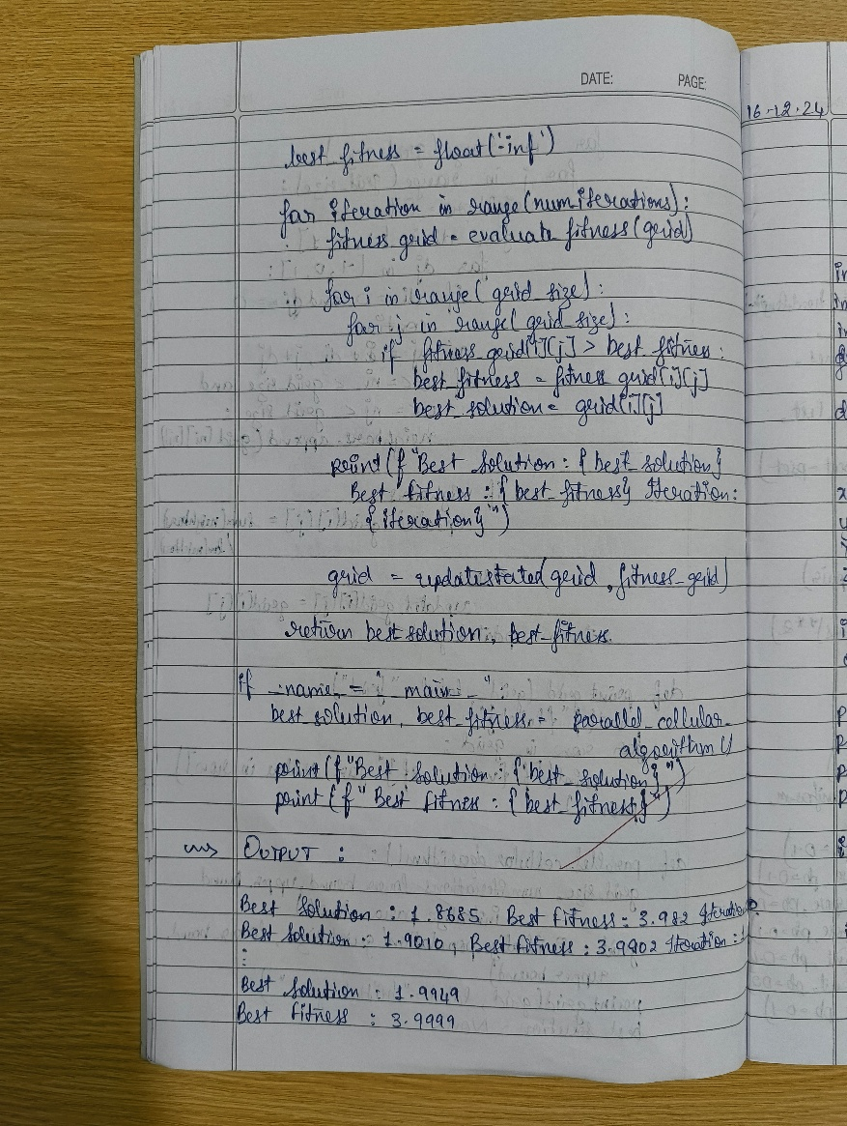

Code

import random

# Student Details

print("Student Name: Likhith M")

print("USN: 1BM22CS135\n")

# Objective Function

def objective_function(x):

return -(x ** 2) + 4 * x

# Initialize Parameters

def initialize_parameters():

grid_size = 10 # Grid size

num_iterations = 50 # Number of iterations

lower_bound, upper_bound = -10, 10 # Bounds for the grid values

return grid_size, num_iterations, lower_bound, upper_bound

# Initialize Population Grid

def initialize_population(grid_size, lower_bound, upper_bound):

grid = [[random.uniform(lower_bound, upper_bound) for _ in range(grid_size)] for _ in range(grid_size)]

return grid

# Evaluate Fitness Grid

def evaluate_fitness(grid):

fitness_grid = [[objective_function(cell) for cell in row] for row in grid]

return fitness_grid

# Update Grid States Based on Neighbor Averages

def update_states(grid, fitness_grid):

grid_size = len(grid)

updated_grid = [[0] * grid_size for _ in range(grid_size)]

for i in range(grid_size):

for j in range(grid_size):

neighbors = []

for di in [-1, 0, 1]:

for dj in [-1, 0, 1]:

if di == 0 and dj == 0:

continue

ni, nj = i + di, j + dj

if 0 <= ni < grid_size and 0 <= nj < grid_size:

neighbors.append(grid[ni][nj])

if neighbors:

updated_grid[i][j] = sum(neighbors) / len(neighbors)

else:

updated_grid[i][j] = grid[i][j]

return updated_grid

# Print Grid State

def print_grid(grid, label="Grid"):

print(f"{label}")

for row in grid:

print([f"{value: .4f}" for value in row])

print()

# Parallel Cellular Algorithm

def parallel_cellular_algorithm():

grid_size, num_iterations, lower_bound, upper_bound = initialize_parameters()

grid = initialize_population(grid_size, lower_bound, upper_bound)

print_grid(grid, label="Initial Grid")

best_solution = None

best_fitness = float('-inf')

for iteration in range(num_iterations):

fitness_grid = evaluate_fitness(grid)

for i in range(grid_size):

for j in range(grid_size):

if fitness_grid[i][j] > best_fitness:

best_fitness = fitness_grid[i][j]

best_solution = grid[i][j]

# Output progress at multiples of 10 iterations

if iteration % 10 == 0 or iteration == num_iterations - 1:

print(f"Iteration {iteration}: Best Solution = {best_solution:.4f}, Best Fitness = {best_fitness:.4f}")

grid = update_states(grid, fitness_grid)

return best_solution, best_fitness

# Main Function

if __name__ == "__main__":

best_solution, best_fitness = parallel_cellular_algorithm()

print("\nFinal Results:")

print(f"Best Solution: {best_solution:.4f}")

print(f"Best Fitness: {best_fitness:.4f}")

Output

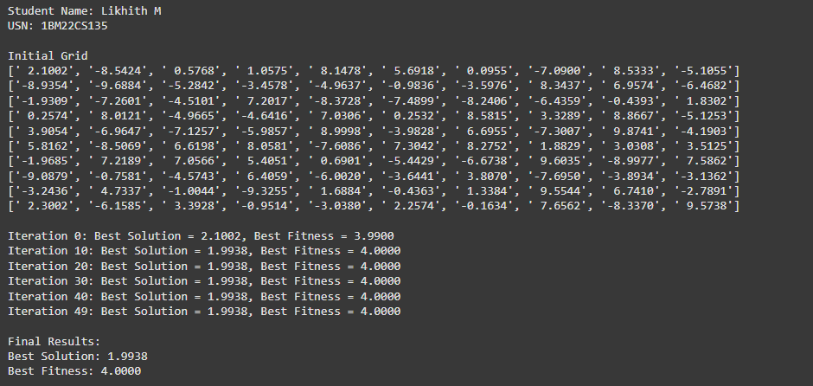

**Laboratory Program - 7**

**Optimization via Gene Expression Algorithms**

Gene Expression Algorithms (GEA) are inspired by the biological process of gene expression in living organisms. This process involves the translation of genetic information encoded in DNA into functional proteins. In GEA, solutions to optimizatsion problems are encoded in a manner similar to genetic sequences. The algorithm evolves these solutions through selection, crossover, mutation, and gene expression to find optimal or near-optimal solutions. GEA is effective for solving complex optimization problems in various domains, including engineering, data analysis, and machine learning.

Algorithm

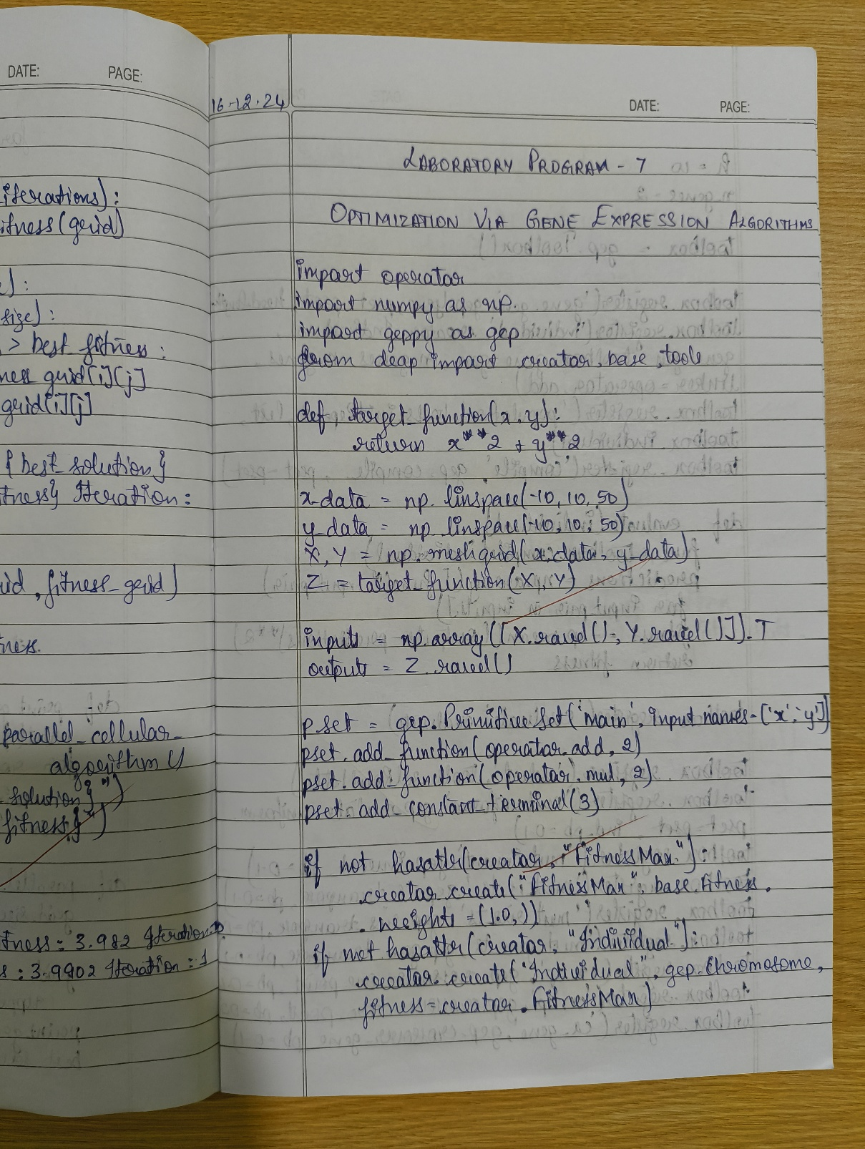

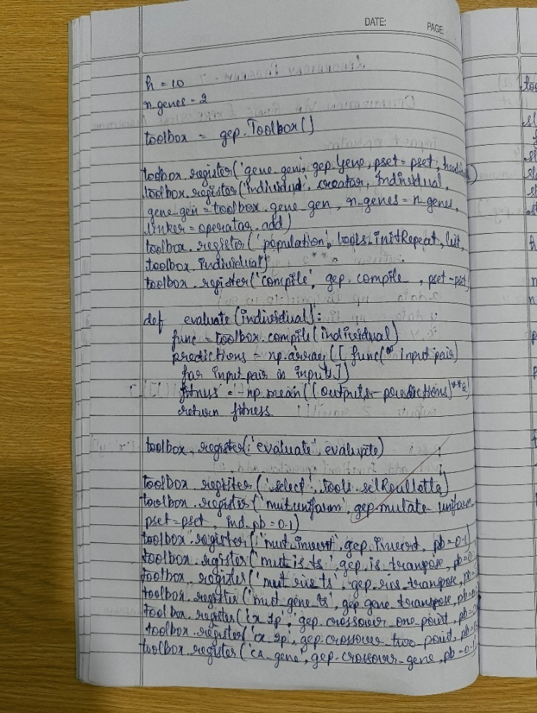

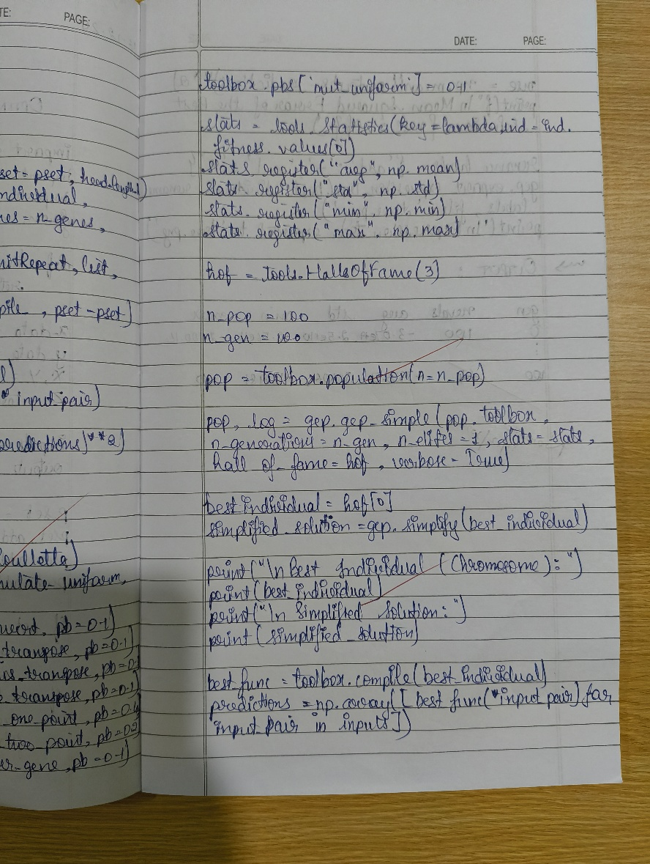

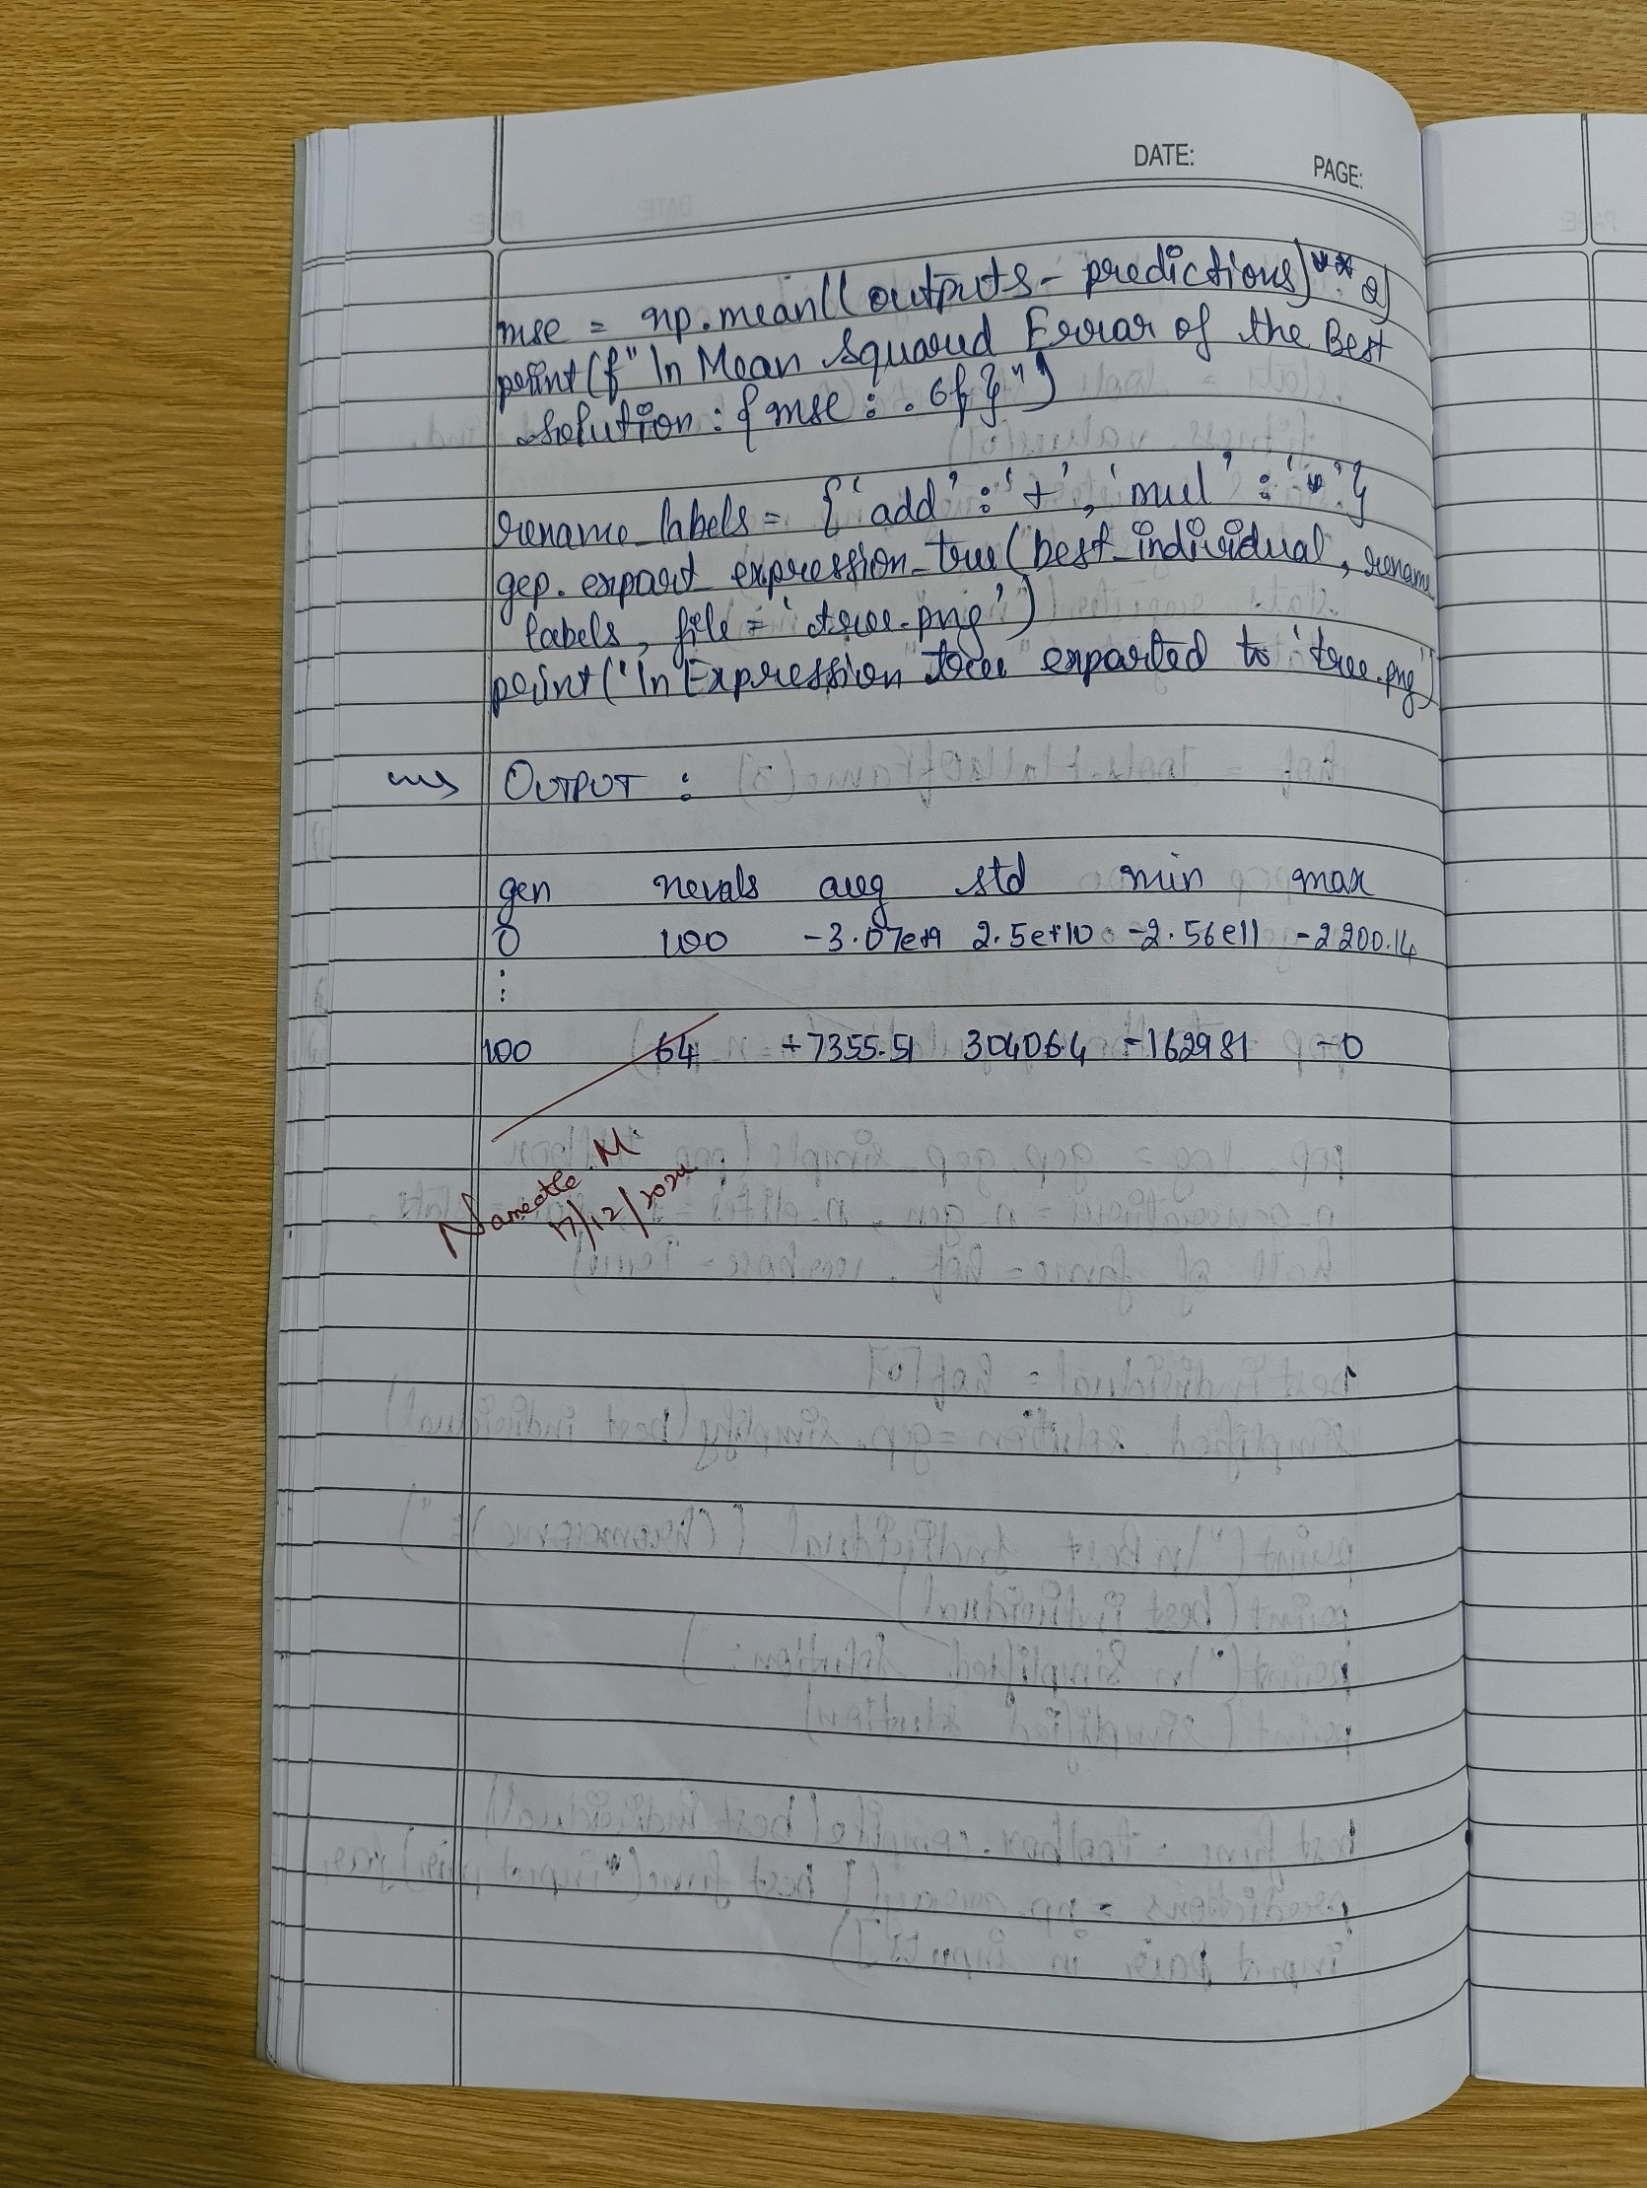

Code

import operator

import numpy as np

import geppy as gep

from deap import creator, base, tools

# Student Information

print("Student Name: Likhith M")

print("USN: 1BM22CS135\n")

# Step 1: Define the target function

def target_function(x, y):

return x**2 + y**2

# Step 2: Define the dataset

x_data = np.linspace(-10, 10, 50)

y_data = np.linspace(-10, 10, 50)

X, Y = np.meshgrid(x_data, y_data)

Z = target_function(X, Y) # Target outputs

# Flatten the data for evaluation

inputs = np.array([X.ravel(), Y.ravel()]).T

outputs = Z.ravel()

# Step 3: Define the GEP primitive set

pset = gep.PrimitiveSet('main', input_names=['x', 'y'])

pset.add_function(operator.add, 2)

pset.add_function(operator.mul, 2)

pset.add_constant_terminal(3)

# Step 4: Define the fitness and individual

if not hasattr(creator, "FitnessMax"):

creator.create("FitnessMax", base.Fitness, weights=(1.0,))

if not hasattr(creator, "Individual"):

creator.create('Individual', gep.Chromosome, fitness=creator.FitnessMax)

# Define head length and number of genes

h = 10 # Set head length to a suitable value

n_genes = 2 # Adjusted to ensure compatibility with the linker

# Step 5: Define the toolbox

toolbox = gep.Toolbox()

# Register chromosome, population, and compile function

toolbox.register('gene_gen', gep.Gene, pset=pset, head_length=h)

toolbox.register('individual', creator.Individual, gene_gen=toolbox.gene_gen, n_genes=n_genes, linker=operator.add)

toolbox.register('population', tools.initRepeat, list, toolbox.individual)

toolbox.register('compile', gep.compile_, pset=pset)

# Define the fitness evaluation function

def evaluate(individual):

func = toolbox.compile(individual)

predictions = np.array([func(*input_pair) for input_pair in inputs])

fitness = -np.mean((outputs - predictions)**2) # Negative MSE

return fitness,

toolbox.register('evaluate', evaluate)

# Register selection, mutation, and crossover operators

toolbox.register('select', tools.selRoulette)

toolbox.register('mut_uniform', gep.mutate_uniform, pset=pset, ind_pb=0.1)

toolbox.register('mut_invert', gep.invert, pb=0.1)

toolbox.register('mut_is_ts', gep.is_transpose, pb=0.1)

toolbox.register('mut_ris_ts', gep.ris_transpose, pb=0.1)

toolbox.register('mut_gene_ts', gep.gene_transpose, pb=0.1)

toolbox.register('cx_1p', gep.crossover_one_point, pb=0.4)

toolbox.register('cx_2p', gep.crossover_two_point, pb=0.2)

toolbox.register('cx_gene', gep.crossover_gene, pb=0.1)

# Explicitly set probabilities for the operators in Toolbox.pbs

toolbox.pbs['mut_uniform'] = 0.1 # Set the probability for mut_uniform

# Step 6: Define statistics and Hall of Fame

stats = tools.Statistics(key=lambda ind: ind.fitness.values[0])

stats.register("avg", np.mean)

stats.register("std", np.std)

stats.register("min", np.min)

stats.register("max", np.max)

hof = tools.HallOfFame(3)

# Step 7: Set population size and generations

n_pop = 100

n_gen = 5

pop = toolbox.population(n=n_pop)

print("Starting Genetic Programming Evolution...\n")

# Start evolution

pop, log = gep.gep_simple(pop, toolbox, n_generations=n_gen, n_elites=1,

stats=stats, hall_of_fame=hof, verbose=True)

# Step 8: Output the best individual

best_individual = hof[0]

simplified_solution = gep.simplify(best_individual)

print("\nBest Individual (Chromosome):")

print(best_individual)

print("\nSimplified Solution:")

print(simplified_solution)

# Evaluate the error of the solution

best_func = toolbox.compile(best_individual)

predictions = np.array([best_func(*input_pair) for input_pair in inputs])

mse = np.mean((outputs - predictions)**2)

print(f"\nMean Squared Error of the Best Solution: {mse:.6f}")

# Export the expression tree

rename_labels = {'add': '+', 'mul': '*'}

gep.export_expression_tree(best_individual, rename_labels, file='tree.png')

print("\nExpression tree exported to 'tree.png'.")

Output

